Halifax Car Rental – Technical Report

CSCI4176: Mobile Computing

2019-12-01

Megan Brock Samath Scott
B00728460 B00689755

Abstract
This is a technical report for Halifax Car Rental, an application designed for use by customers and representatives of an imagined car rental agency in Halifax.
All minimum functionality has been implemented, as well as most expected functionality. One expected feature, to be able to trace a route and determine rental fees incurred based on distance travelled has been partially completed. Two out of three bonus functionalities were implemented. The bonus functionality to use facial recognition to log in to the application was not implemented.

Minimum Functionality
- Map with location markers (Completed)
- Ability to take and send photos in chat (Completed)
- Text chat communication (Completed)
Expected Functionality
- Route tracing and cost determination (Partially Completed)
  - Route can be determined in the application, but there is no cost determination by distance travelled.
- Augmented reality car location markers (Completed)
- Audio chat communication (Completed)
Bonus Functionality
- Ability to see available cars, rent and return from the map (Completed)
- Video chat communications (Completed)
- Face recognition for application sign in (Not Implemented)

Description
The purpose of this application is to allow users who are customers or administrators of a car rental agency to quickly find rental cars near them. The agency’s rental cars are picked up and dropped off by the user in various locations in Halifax. Should there be any problem with a car, representatives of the car rental agency will retrieve the car.
Many features of this application have been designed speed up the process of locating a car. Other features have been designed as communication tools between customers and an administrator.
Although many applications exist for car rental agencies, many of them focus on the financials of car rental. Although this is a necessary part of the process, this application is designed to help the user accomplish their goal faster. For the customers, this goal is to reach their destination. For employees, this is to locate and retrieve rental cars that need servicing or repair. Both of these users could benefit from a mobile application that helps them quickly find rental cars.
Users
Users of the application will be people who are looking to rent a car in the Halifax regional municipality (HRM) and employees of the rental agency who maintain rental cars.
The targeted userbase includes people who live in or visit the HRM who are able to drive, or who are of working age. As such, the userbase consists of users who are at least 16 years of age.
Users are expected to be adults who are familiar with using mobile devices.
Most customers are expected to be those who live in the HRM. These users likely do not own cars, however, have some need to drive. They are more likely to be willing to download an application that is locked to this location.
Other customers are expected to be visiting the area without their car, should they own one. They are less likely to download an application that they may only need for a short period of time.
Administrative users are employees of the rental agency, who must be able to locate rental cars owned by the company.
Customers and administrative users must be able to communicate with each other.

Features
- Find the fastest route to a rental car: The user can select a rental car on a map and view multiple routes to the car. The routes include the duration, and the quickest route is highlighted. The car can be rented at any time; the user can rent a car before they arrive at it's location.
- Easily identify rental cars in the world: The application aids the user to identify rental cars. When renting a car, the user is presented with a detailed view of the cars details, including the make, model, and year of the car, as well as an image for users who may not recognize a car using those terms. Additionally, the augmented reality feature of the application superimposes location markers into the real-world in the (approximate) locations of available rental cars.
- In-app communication with the rental agency: There is a chat system in place to allow the user to communicate using text, audio, image, and video with a representative of the rental agency. The client should be able to communicate quickly and easily with the agency, without having to remember or look up contact information.

Libraries
Google play services
com.google.android.gms:play-services-auth:8.4.0
com.google.android.gms:play-services-maps:17.0.0
com.google.android.gms:play-services-location:17.0.0
Google maps
com.google.maps.android:android-maps-utils:0.5+
com.google.maps:google-maps-services:0.2.9
Sceneform
com.google.ar.sceneform:core:1.10.0
com.google.ar.sceneform.ux:sceneform-ux:1.10.0
FireBase
com.google.firebase:firebase-core:16.0.7
com.google.firebase:firebase-firestore:17.1.5
com.google.firebase:firebase-analytics:16.1.5
com.google.firebase:firebase-storage:16.0.1
com.google.firebase:firebase-database:16.0.1

Other dependencies
com.firebaseui:firebase-ui-firestore:4.3.1 FirebaseUI is a library used for connecting UI elements to Firebase. Source [here]( https://github.com/firebase/FirebaseUI-Android/releases)
org.slf4j:slf4j-nop:1.7.25 Source [here](http://www.slf4j.org/)
de.hdodenhof:circleimageview:2.2.0 CircleImageView is a circular version of an ImageView. Source [here](https://github.com/hdodenhof/CircleImageView)
com.xwray:groupie:2.1.0 Groupie is a RecyclerView layout helper library. Source [here]( https://github.com/lisawray/groupie)
com.squareup.picasso:picasso:2.71828 Picasso is a library for downloading and caching images in Android. Source [here]( https://github.com/square/picasso)
com.github.appoly:ARCore-Location:1.0.5. Appoly ARCore Location allows objects to be placed in ARCore using geographic coordinates. Source [here](https://github.com/appoly/ARCore-Location)
arcore-for-all. ARCore for all is a library that allows devices that are not supported by ARCore, yet have the appropriate hardware to run ARCore, to do so. It replaces the arcore_client library with a modified version. Source [here](https://github.com/tomthecarrot/arcore-for-all)
Kameleon Free Pack - Rounded. Icon set by Webalys on ICONFINDER. Source [here](https://www.iconfinder.com/iconsets/kameleon-free-pack-rounded)
Circle Icons. Icon set by Nick Roach on ICONFINDER. Source [here](https://www.iconfinder.com/iconsets/circle-icons-1)
Camera, dual, iphone 7 icon. Icon by Webalys ICONFINDER. Source [here](https://cdn0.iconfinder.com/data/icons/iphone-7-airpods-icons-solid-style/24/dual-camera-2_1-128.png)
Car Placeholder Free. Icon by Freepik on FLATICON. Source [here](https://www.flaticon.com/free-icon/car-placeholder_75782.)
Plus icon. Icon on ICONFINDER. Source [here](https://cdn4.iconfinder.com/data/icons/keynote-and-powerpoint-icons/256/Plus-128.png)
Refresh Icons. Icons on icons8. Source [here](https://icons8.com/icons/set/refresh)
Chat High Quality PNG. Icon by Pyare on pngriver. Source [here](https://pngriver.com/download-chat-high-quality-png-100130/)
Focus2move: World Best Selling Car - The top 100 in 2019. Images on focus2move. Source [here](https://focus2move.com/world-best-selling-car/)
Map Marker. Icon by Chris Ross on poly.google.com. Source [here](https://poly.google.com/view/6ij4nru_NPh)

Requirements
- Android 7.0, minimum sdk version 24.
- Camera and image capture permissions
- Audio recording permissions
- Location permissions
- Read and write to external storage permissions

Installation Notes
To run on an emulator:
- Requires Android Studio 3.1 and Android Emulator 27.2.9 or later.
- Development machine must support OpenGL ES 3.0 or later.
- Emulated device must be Pixel or Pixel 2, with the "Oreo: API Level 27: x86: Android 8.1" system image.
- See https://developers.google.com/ar/develop/java/emulator
To run on a device:
- Device must be supported by ARCore. See https://developers.google.com/ar/discover/supported-devices for lists of ARCore supported devices.
Most features of the application require permissions to function. See "Requirements" section above for required permissions.

Final Project Status
All minimum functionality was completed. There is a map page where the user can see markers for rental car locations, car drop-off locations, and the rental agency location.
There is a chat system in place for communication between an administrative user and each client user. The administrator has a list of active chats with clients. Selecting a client from the list will open the chat log between the administrator and that user. Similarly, the user has a chat log between themselves and the administrator. The client does not have a list of active chats; as far as the user is concerned they communicate with a single administrative entity.
The user can take photos in the application and send them to an administrator. Likewise, the administrator can take and send photos to the client.
Two of the expected functionalities were completely implemented, and one was partially implemented.
The partially completed functionality is route tracing and rental fee determination based on distance travelled. Currently, the user is able to find multiple routes to a destination and highlight one of their choice. However, there is no distance tracking and the rental fees are fixed based on the car rented.
The expected networking task, to allow audio communication between clients and the administrator, has been completed. Users can record and send audio on the chat page of the application.
The augmented reality functionality has also been implemented. The user can launch an augmented reality activity, where the location of each rental car is represented with a 3D marker as well as a 2D information card. Clicking on either marker will open a page with details of the car. From this page, the user can rent the car. Although this functionality has been completed, due to technical limitations the markers are not very stable, which affects the usability of the feature. Other solutions to placing virtual objects using geolocation have been investigated, however there was not enough time left during development to implement one.
Finally, two of the three bonus functionalities have been implemented. The bonus functionality to have facial recognition as a log in method was not implemented.
The bonus feature to rent and return a car using the location markers on the map has been implemented. As this feature is important for the function of the application, it should have been moved to expected functionality, and the route tracing functionality should have replaced it in the bonus section.
Video communication, the bonus networking task, has also been completed. Both the client and administrator can take and send videos in the chat section of the application.

Code Examples
Problem 1: We needed to show car details from the AR activity. As it is difficult to press a button on the view in augmented reality, instead the user is brought to the CarDetails activity when the view or marker is pressed.
// The method to make a 3D model location marker and add an OnTapListener.
private fun getMarker(car: Car) : Node {
val node = Node()
node.renderable = modelRenderable
node.setOnTapListener {hitTestResult, motionEvent ->
ShowCarInfo(car)
}
return node
}

// The method to make a 2D view location marker and add an OnTapListener.
private fun getView(car: Car) : Node {
val node = Node()
if (car.isavaliable)
node.renderable = availableCarLayoutRenderable
else node.renderable = rentedCarLayoutRenderable
node.setOnTapListener {hitTestResult, motionEvent ->
ShowCarInfo(car)
}
return node
}

// The method to start the CarDetails activity, with the car name as a key.
private fun ShowCarInfo(car: Car) {
val intent = Intent(this, CarDetails::class.java)

val sharedData = Globals.instance
sharedData.car_name = car.name
startActivity(intent)
}
Problem 2: We needed a way to selectively return to an activity based on who the logged in user is. Specifically, we needed to return to the ChatList activity from the ChatLog fragment for admin users, but not for client users - as clients only have one person to talk to, they don't use the ChatList activity.
// The ChatListFragment that is only used for admin users, to select a client to chat with. The client has no use for this page, as they will only communicate directly to the administrator.
class ChatListFragment : Fragment() {
override fun onViewCreated(view: View, savedInstanceState: Bundle?) {
super.onViewCreated(view, savedInstanceState)

(activity as AppCompatActivity)!!.supportActionBar?.title = "Chat"

recyclerview_user_log.adapter = adapter

getUsers()

val sharedData = Globals.instance
// here we can tell the user is not an administrator. We skip past this // fragment and send them to the ChatLog fragment instead.
// we don’t want this user to return to the ChatList when they press the // back button, so we call goToChatLog with addToBackstack = false.
if(sharedData.username != "admin")
{
sharedData.talkTo = "admin"
goToChatLog(false)
}
}

companion object {
lateinit var fragment: Fragment
// adds the fragment transaction to the backstack if addToBackstack is true
// this allows us to choose when this fragment will be skipped over when the // back button is pressed, and prevent the client user from returning to the // chat list page.
fun goToChatLog(addToBackstack: Boolean) {
val transaction = fragment!!.childFragmentManager.beginTransaction()
val chatLog: Fragment = ChatLogFragment()
transaction.replace(R.id.constraintLayout, chatLog)
if (addToBackstack) {
transaction.addToBackStack(null)
}
transaction.commit()
}
}
...
}

// The ChatListItem that appears in UserList. We already know the user is an admin.
class ChatListItem(val userName: String, val userImage: String): Item<ViewHolder>() {
override fun bind(viewHolder: ViewHolder, position: Int) {
viewHolder.itemView.txtName.text = userName

val uri = userImage
val targetImageView = viewHolder.itemView.img_Car_Img
Picasso.get().load(uri).into(targetImageView)

viewHolder.itemView.img_Car_Img?.setOnClickListener(
object: View.OnClickListener {
override fun onClick(view: View) {
setUser()

// The user has pressed on the item. We send the user to the // ChatLog. However, we want the user to return to the ChatList page //when they press the back button, so we set addToBackstack = true //when we call goToChatLog.
ChatListFragment.goToChatLog(true)
}
})

viewHolder.itemView.txtName?.setOnClickListener(
object: View.OnClickListener {
override fun onClick(view: View) {
setUser()
// Same as above, we want the user to return to the ChatList //fragment when they press the back button, so we want to add the //ChatList to the backstack.
ChatListFragment.goToChatLog(true)
}
})
}
...
}

Problem 3: We needed the user to be able to highlight a specific route out of the many given to their destination. First, the routes must be calculated and drawn. Once this is done, we needed a way to know when the user has pressed on a route. Finally, when the pressed route is known, it must be highlighted.

class MapFragment : Fragment(), OnMapReadyCallback, GoogleMap.OnPolylineClickListener {
// creates routes between the users location and a chosen marker on the map
private fun calculateDirections(marker:Marker) {
var destination = com.google.maps.model.LatLng(
marker.getPosition().latitude,
marker.getPosition().longitude
)
var directions = DirectionsApiRequest(mGeoApiContext)
directions.alternatives(true)
directions.origin(
com.google.maps.model.LatLng(lat,lang)
)
directions.destination(destination).setCallback(
object:PendingResult.Callback<DirectionsResult> {
override fun onResult(result:DirectionsResult) {
addPolylinesToMap(result)
}
})
}

// highlights the selected route when pressed
override fun onPolylineClick(polyline:Polyline) {
var index = 0
for (polylineData in mPolyLinesData)
{
index++
if (polyline.getId().equals(polylineData.polyline.getId()))
{
polylineData.polyline.setColor(ContextCompat.getColor(activity!!, R.color.blue1))
polylineData.polyline.setZIndex(1f)
val endLocation = LatLng(
polylineData.leg.endLocation.lat,
polylineData.leg.endLocation.lng
)
val marker = mMap.addMarker(MarkerOptions()
.position(endLocation)
.title("Route #" + index)
.snippet("Duration: " + polylineData.leg.duration))
mTripMarkers.add(marker)
marker.showInfoWindow()
}
else
{
polylineData.polyline.setColor(ContextCompat.getColor(activity!!, R.color.darkGrey))
polylineData.polyline.setZIndex(0f)
}
}
}
...
}

Functional Decomposition
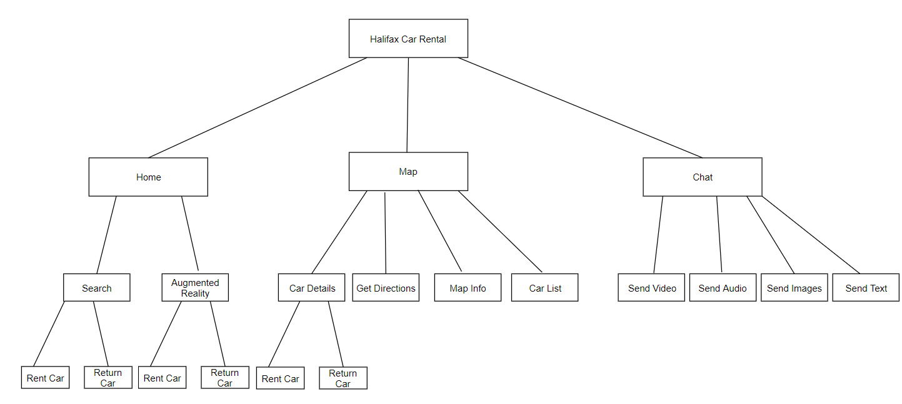

High-level Organization

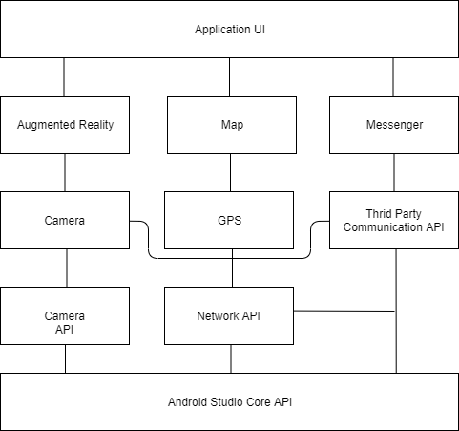

Clickstreams
1. A user wants to rent a car. They launch the app, they sign in. Here there are three separate paths, a, b, and c.
- They navigate to the map page. They tap a marker on the map, indicating an available rental car. The user chooses to rent this car.
- They remain on the home page. They press the primary action button on the home page labeled Find a Car. They enter a search term. They select a car from the results. The user chooses to rent this car.
- The user navigates to the augmented reality page. They tap a location marker on the screen. The details of the car represented by the marker are shown to the user. The user chooses to rent this car.
Once the car has been rented, it is displayed on the home page.

2. A user has a car they want to return. The user brings the car to a rental car drop-off location.
The user navigates to the home page of the application. Here there is a small card displaying information of the currently rented car. Underneath, there is a button to return the car. The user presses this button, and the car is returned.

3. A user has a rented car. The user wants to know how much cost they have incurred in rental and travel fees.
The user navigates to the home page. Here there is information about the currently rented car. The rental and travel fees, as well as the total fees, are displayed along with other car details.

4. The user has encountered a situation where they must get in contact with a representative of the car rental agency.
The user navigates to the chat page.
- The user wants to send a text message. The user types in the input field, then presses send. The message is sent to an administrative user.
- The user wants to send a picture, audio, or video message. The user presses the floating action button. Options for picture, audio, and video appear as additional buttons. The user selects the button corresponding to the action they want to take. The user then records audio, takes a picture or records a video. The user confirms the action. A message is automatically sent with the content created.

Layout
The main, map, and chat activities are the primary pages of the application. These are accessible using the bottom navigation tabs. The sign in activity is the first page of the application. After signing in, the user is brought to the home page.
The search activity is a sub-page of the home page, which is reached by pressing the search button on the home page. Similarly, the augmented reality activity is launched when the corresponding button is pressed.

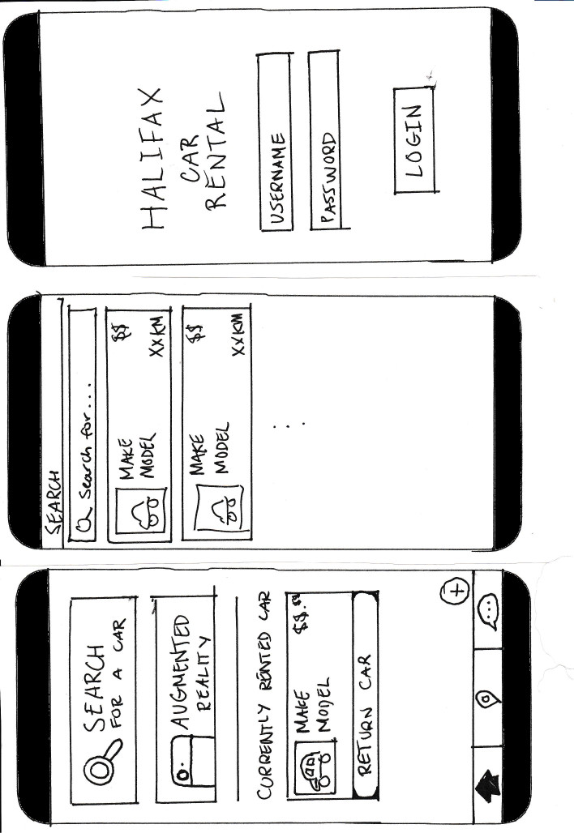
Figures 1, 2. Left to right: sign in page, home page.

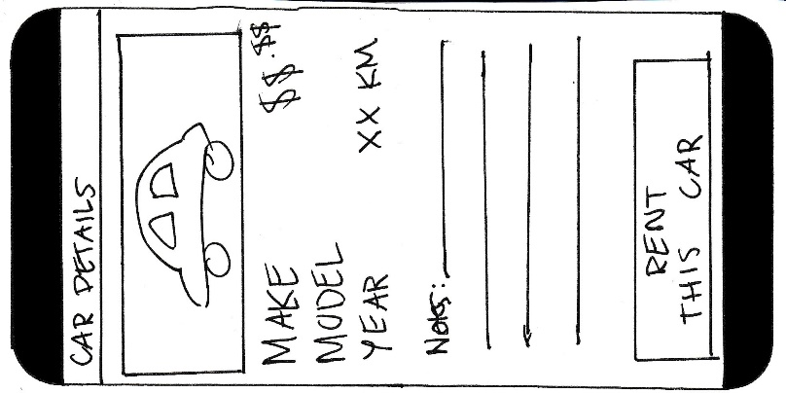
Figures 3, 4. Left to right: Search page, car details page. Pressing a car in the search results will open the car details page for the corresponding car.

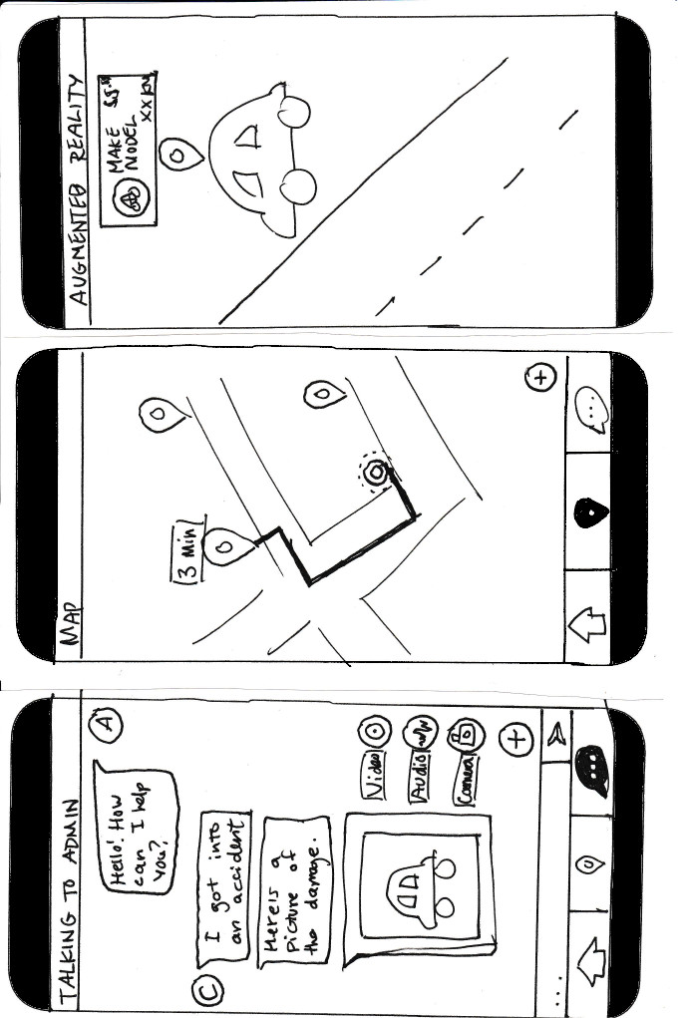
Figures 5, 6. Left to right: Augmented reality page, car details page. Pressing a car marker in augmented reality will open the car details page for the corresponding car. This is the same page used for cars in the search page results.
Figures 7, 8. Left to right. Map page, car details page. Rental car, parking spot, and rental agency locations can be seen by any user. Rented cars can be seen by administrators. Directions can be found to any location. Pressing on a car marker and choosing to see it’s details will open the same car details page used in search results and augmented reality.

Figure 9. Chat page. A customer and administrator can exchange messages in text, picture, audio, or video format.
Implementation
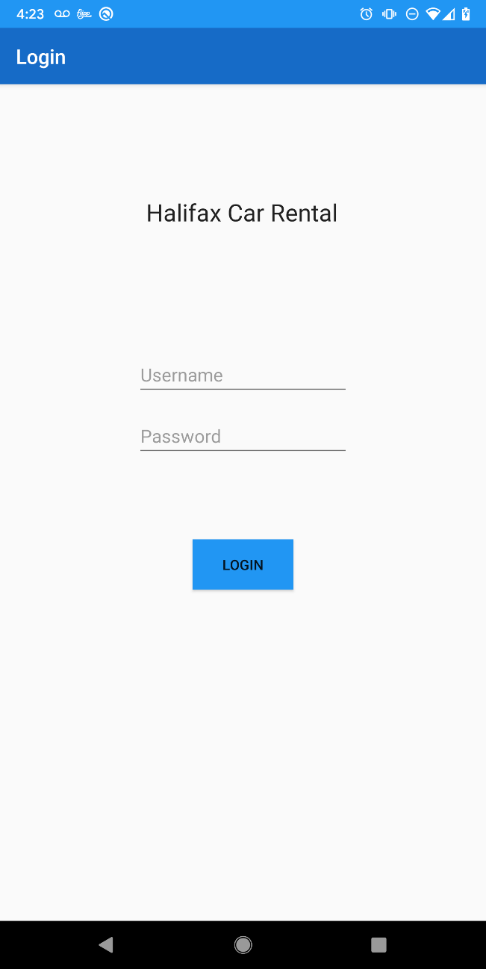
Figure 1. The log in page.
On this page, the user must enter a valid username and password, then press the login button. On success, the user will be redirected to the home page. On failure, a message will be displayed prompting the user to enter valid credentials.

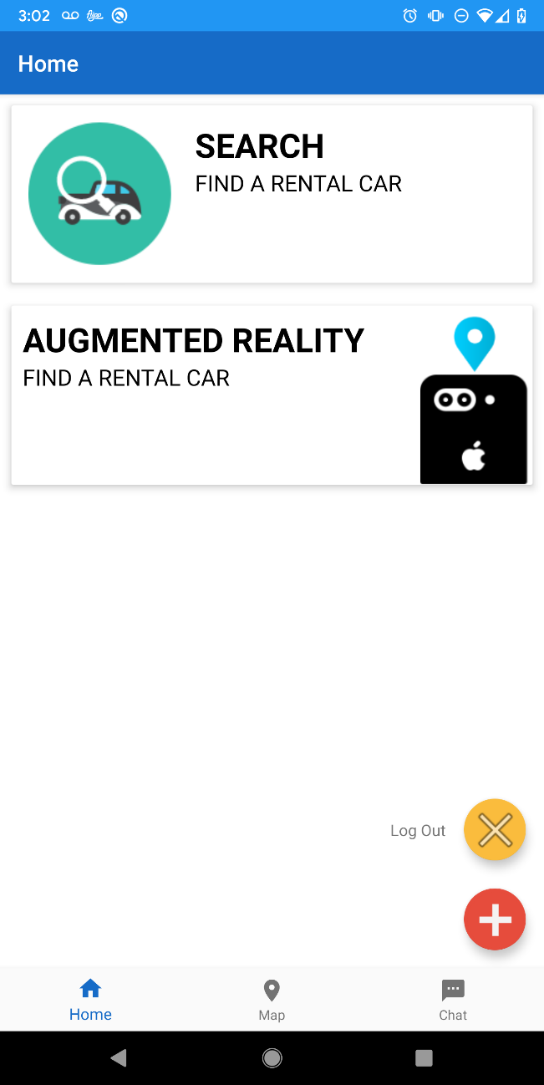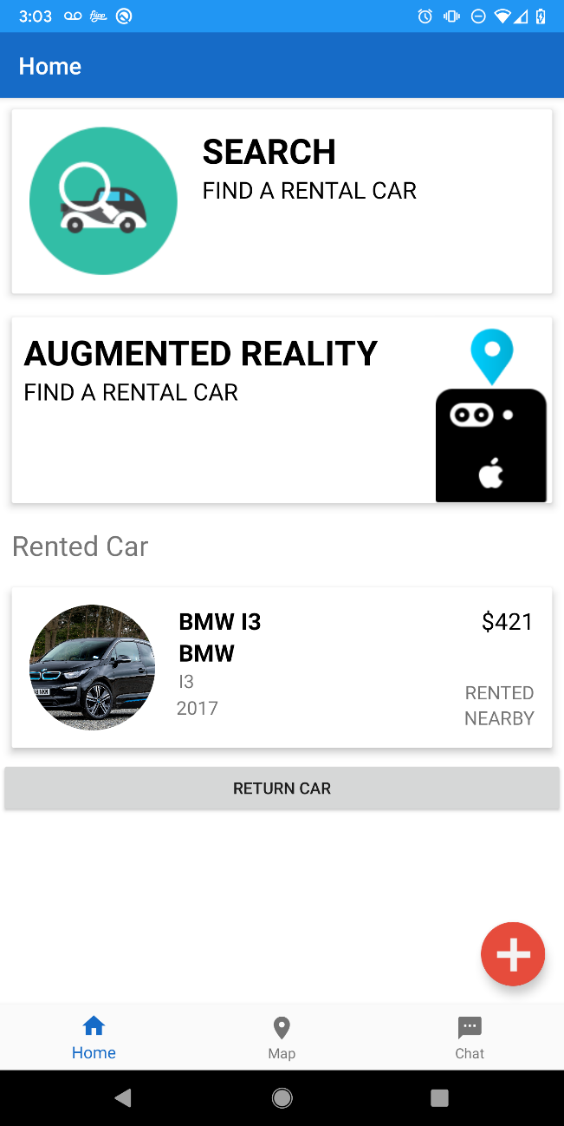
Figures 2, 3. Left to right: Home page with floating actions expanded and no rented car, home page with floating actions closed and a rented car.
On this page the user can press the search or augmented reality cards to be directed to those pages. The user can expand the floating action button and press the “Log Out” button, after which they will be logged out and returned to the log in page. If the user has a rented car, it will be displayed. The user can return the car by pressing the “Return Car” button.
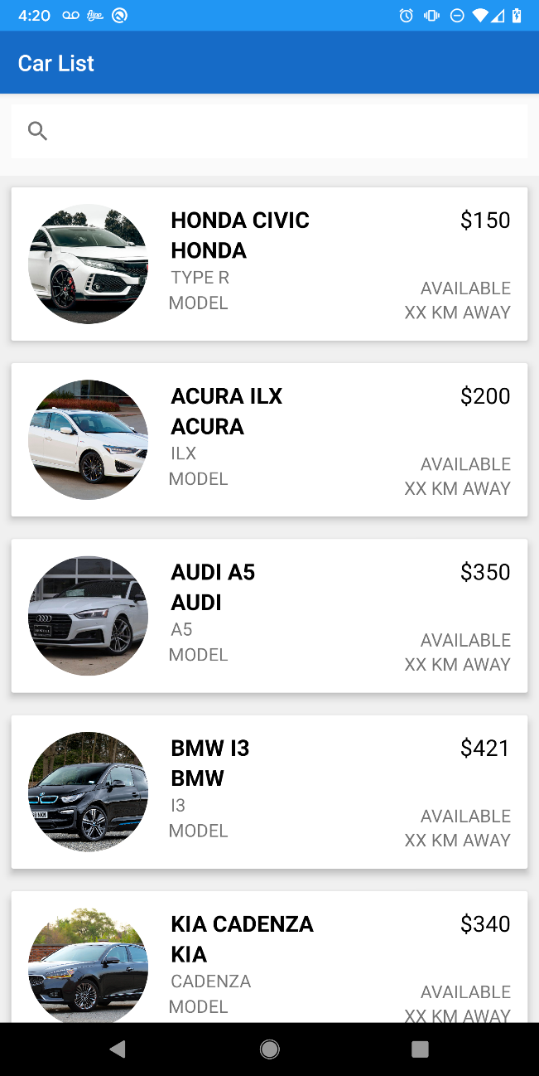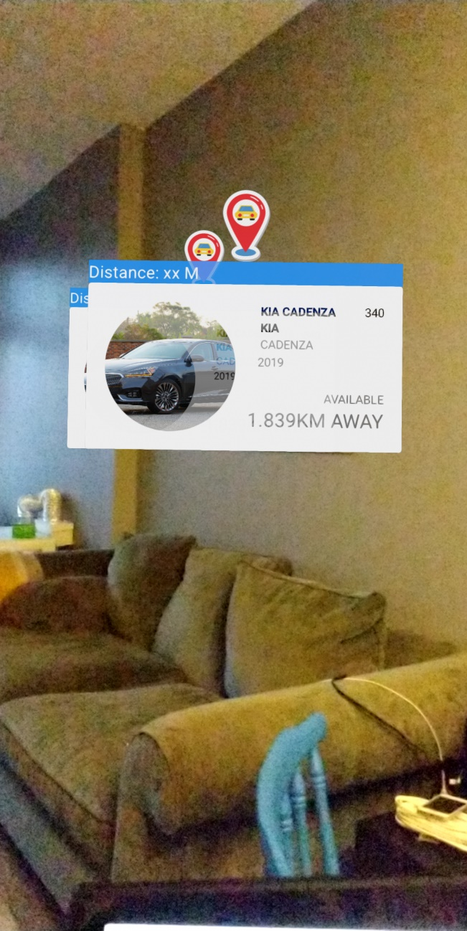
Figures 4, 5. Left to right: The search page, the augmented reality page. Both pages are sub-pages of the home page. A list of available cars is shown in the search page. Cars locations are represented with location markers and car information cards in augmented reality. The user can see car details by pressing on either representation of a rental car.
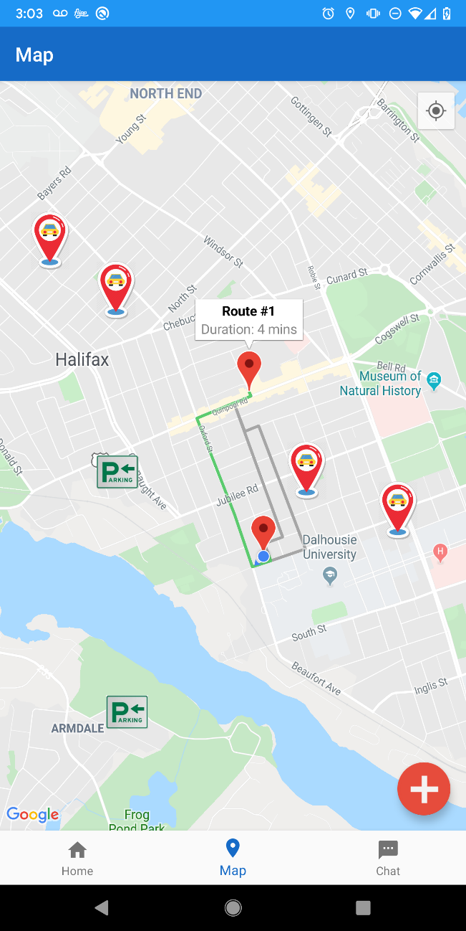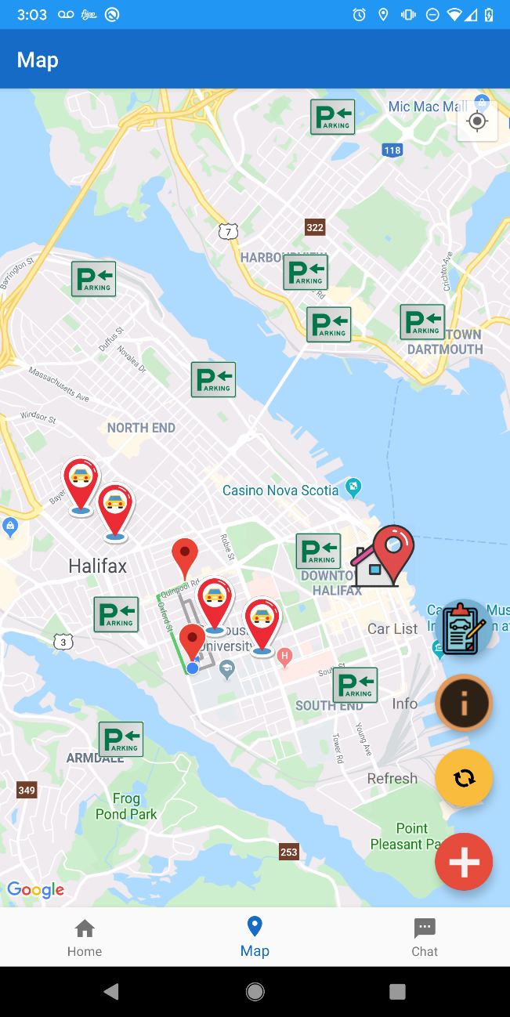
Figures 6, 7. Left to right: The map page with a highlighted route and floating actions closed, the map page with floating actions expanded.
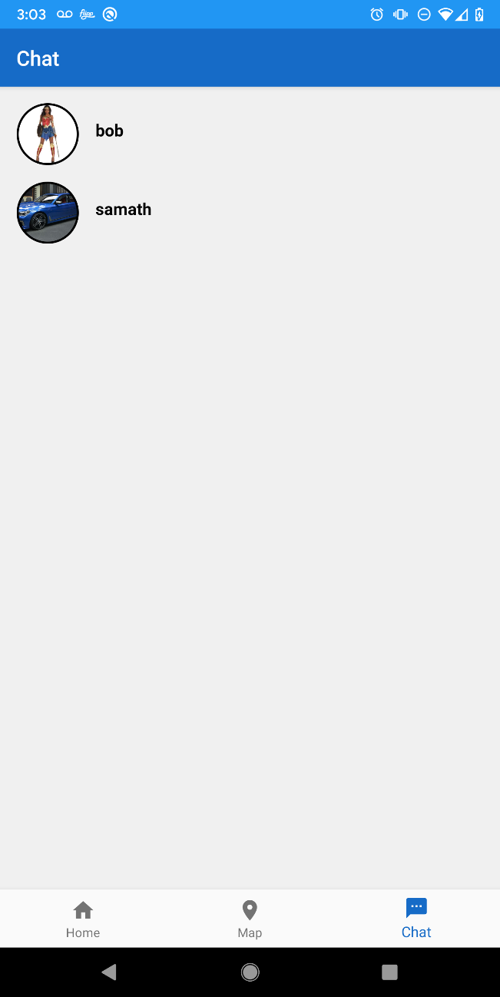
Figure 8. The chat page, as seen by administrative users. There is a list of client users that are currently engaged in conversation with the administrator. Pressing on a user will open the chat log page for the conversation between the administrator and that user.
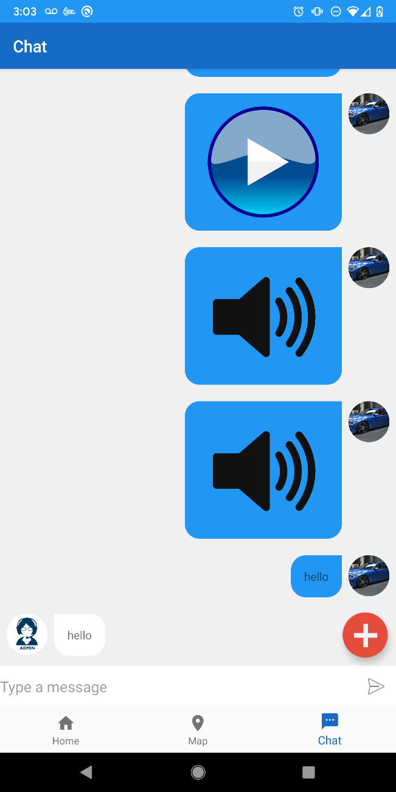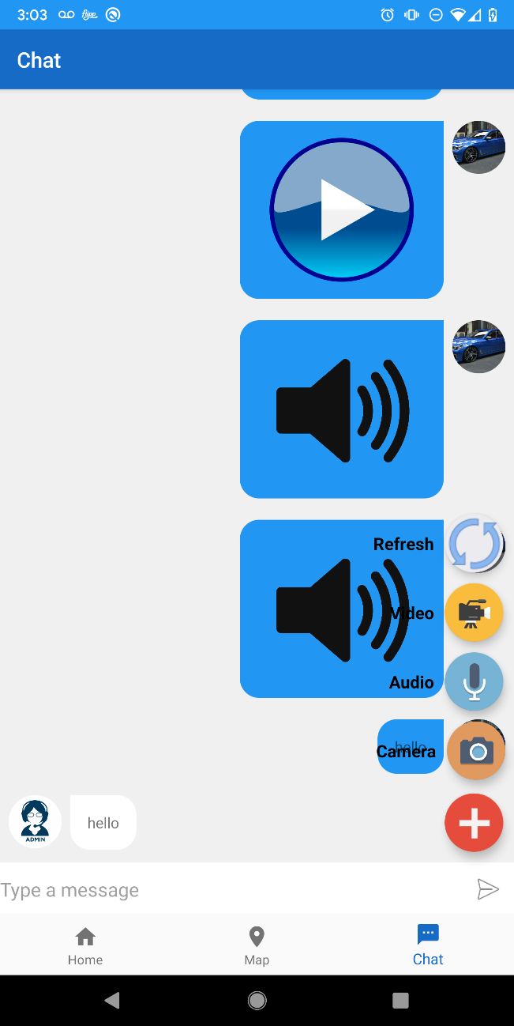
Figures 9, 10. Left to right: The chat log page as seen by the administrator with floating actions closed, the chat log page as seen by the administrator with floating actions expanded. The user who is logged in will see their messages on the left, and the other user’s messages on the right. Note that in the final implementation, the colours of the right and left chat bubbles have been switched.

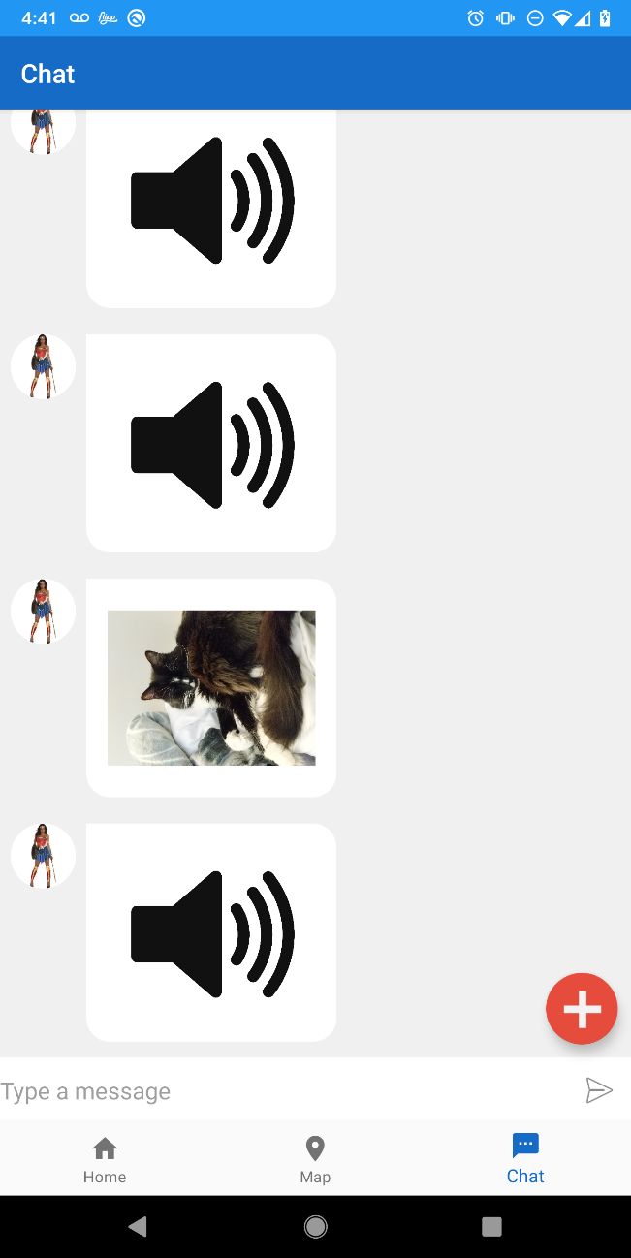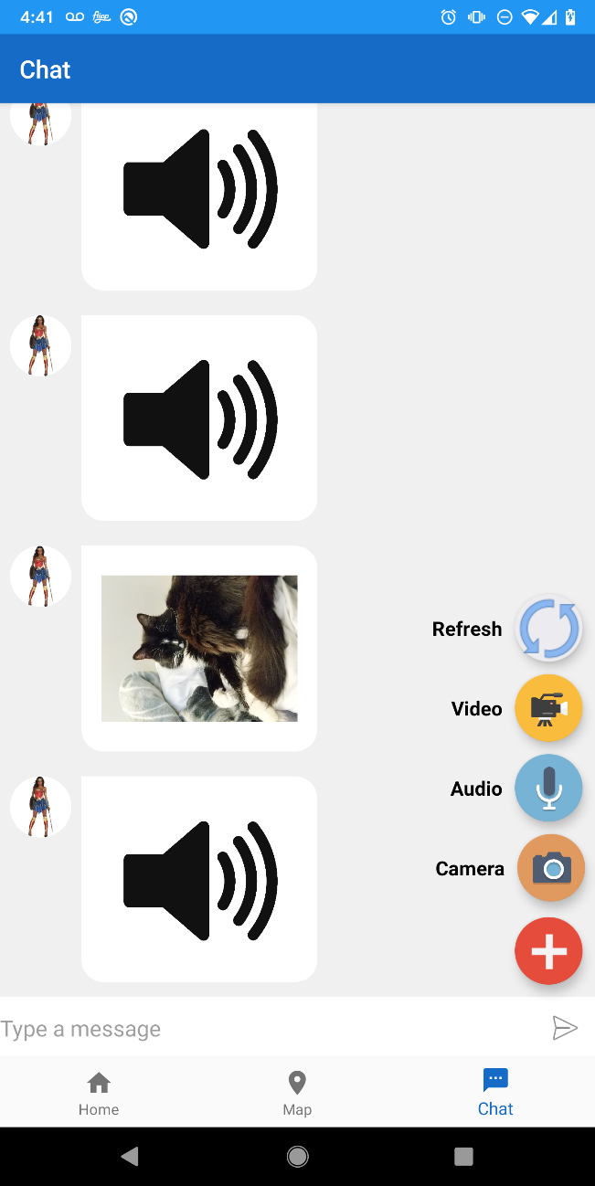
Figures 11, 12. Left to right: The chat log page as seen by a client with floating actions closed, the chat log page as seen by a client with the floating actions expanded.
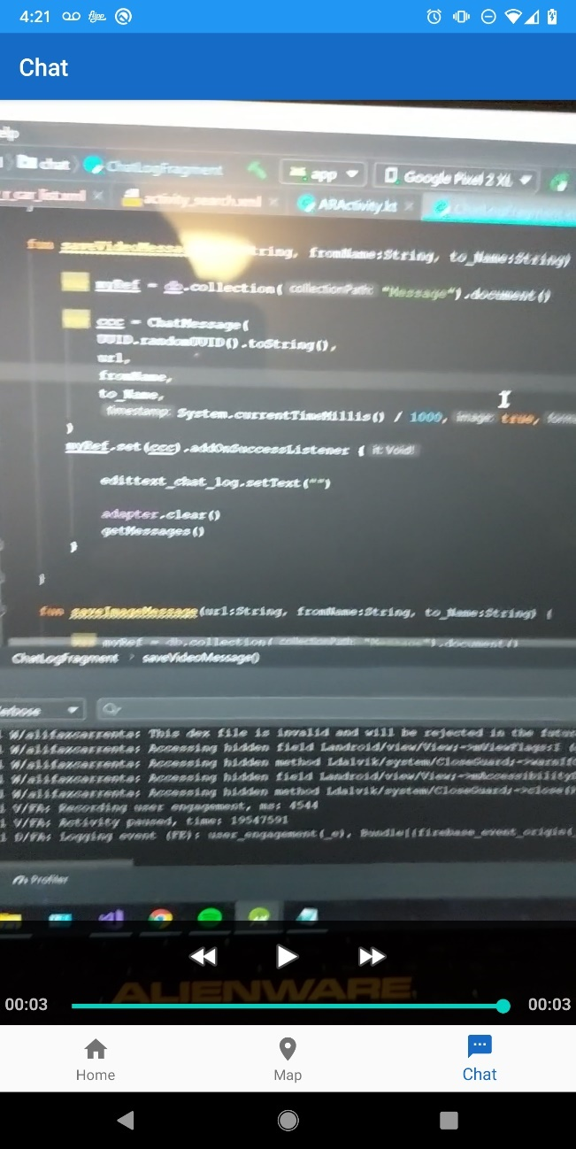
Figure 13. Watching a video that has been sent, as seen by either client or administrator.

Future Work
Although the expected camera functionality, the ability to find rental cars in augmented reality (AR), was completed, the location markers in the AR activity are unstable.
Unfortunately, a solution using the libraries chosen to accomplish this task has not been found.
There is clear evidence that it is possible to place location markers in ARCore with more accuracy than has been accomplished in this project. A project called Geolocation-ARCore, by aishnacodes on GitHub [3] appears to place AR objects using location coordinates with much greater stability, as seen in a video posted by the project’s owner on YouTube [39].
As such, future work could include researching and testing other libraries that allow virtual items to be placed using geolocation.
Other future work includes finishing functionality that is incomplete or not implemented and polishing existing features. One example of this is refactoring the audio player to use a media controller, similar to the video player.
The application was also intended to have a search feature, however other tasks took priority over implementing this feature. Instead, the search page displays a list of all cars available.

Sources
GitHub
[1] Appoly, GitHub. (2018). ARCore Location. [online]
https://github.com/appoly/ARCore-Location (accessed Nov 28, 2019).
[2] Suarez, T. GitHub. (2018). ARCore for All. [online]
https://github.com/tomthecarrot/arcore-for-all (accessed Nov 28, 2019).
[3] A. Agrawal. GitHub. (2018). Geolocation ARCore. [online]
https://github.com/aishnacodes/Geolocation-ARCore (accessed Nov 28, 2019).
[4] Google, GitHub. (2019). ARCore SDK for Android. [online]
https://github.com/google-ar/sceneform-android-sdk/tree/master/samples/hellosceneform (accessed Nov 28, 2019).
[5] Dmytro, GitHub. (2018) Messenger. [online] https://github.com/dmyma/Messenger/blob/master/app/src/main/java/info/sa2rdaymorning/kotlinmessanger/registerlogin/RegisterActivity.kt (accessed Nov 28, 2019).
[6] Stern, S. (2018). FirebaseUI for Android. [online]
https://github.com/firebase/FirebaseUI-Android/releases (accessed Nov 28, 2019).
[7] Dodenhof, H. (2013). CircleImageView. [online]
https://github.com/hdodenhof/CircleImageView (accessed Nov 28, 2019).
[8] Wray, L. (2016). Groupie. [online]
https://github.com/lisawray/groupie (accessed Nov 28, 2019).
[9] Wharton, J. (2018). Picasso. [online]
https://github.com/square/picasso (accessed Nov 28, 2019).

[10] QOS.ch (2019). Simple Logging Facade for Java (SLF4J). [online]
http://www.slf4j.org/ (accessed Nov 28, 2019)

Android and Google Documentation
[11] “ARCore supported devices”, Google Developers. [online]
https://developers.google.com/ar/discover/supported-devices (accessed Nov 28, 2019).
[12] “Create a renderable”, Google Developers. [online]
https://developers.google.com/ar/develop/java/sceneform/create-renderables (accessed Nov 28, 2019).
[13] “Provide custom back navigation”, Android Developers. [online]
https://developer.android.com/guide/navigation/navigation-custom-back (accessed Nov 28, 2019).
[14] “MediaRecorder overview”, Android Developers. [online]
https://developer.android.com/guide/topics/media/mediarecorder (accessed Nov 28, 2019).
[15] “Take photos”, Android Developers. [online]
https://developer.android.com/training/camera/photobasics (accessed Nov 28, 2019).

StackOverflow Questions
[16] "How to get the context inside a nested class?", StackOverflow.
https://stackoverflow.com/questions/48952949/how-to-get-the-context-inside-a-nested-class (accessed Nov 28, 2019).
[17] "Replacing a fragment with another fragment inside activity group", StackOverflow.
https://stackoverflow.com/questions/5658675/replacing-a-fragment-with-another-fragment-inside-activity-group (accessed Nov 28, 2019).
[18] "How to close the current fragment by using Button like the back button?", StackOverflow.
https://stackoverflow.com/questions/20812922/how-to-close-the-current-fragment-by-using-button-like-the-back-button (accessed Nov 28, 2019).
[19] "Android: Parent fragment of a nested fragment", StackOverflow.
https://stackoverflow.com/questions/26991560/android-parent-fragment-of-a-nested-fragment (accessed Nov 28, 2019).
[20] "Removing Fragment by clicking/touching outside", StackOverflow
https://stackoverflow.com/questions/15323424/removing-fragment-by-clicking-touching-outside (accessed Nov 28, 2019).
[21] "getSupportActionBar from inside of Fragment ActionBarCompat", StackOverflow
https://stackoverflow.com/questions/18320713/getsupportactionbar-from-inside-of-fragment-actionbarcompat (accessed Nov 28, 2019).
[22] “Using onResume() to refresh activity”, StackOverflow.
https://stackoverflow.com/questions/6850683/using-onresume-to-refresh-activity (accessed Nov 28, 2019).

Assets
[23] Ross, C. (2017). Map Marker. [model]
https://poly.google.com/view/6ij4nru_NPh (accessed Nov 28, 2019).
[24] Webalys. (2014). Car, list icon.
https://www.iconfinder.com/icons/377493/car_list_icon (accessed Nov 28, 2019).
[25] Wikipedia. (2009). Information.png
https://en.wikipedia.org/wiki/File:Information.png (accessed Nov 28, 2019).
[26] Creative Stall. (2017). Car parking, gps, map pin, parking, placeholder icon
https://www.iconfinder.com/icons/2124530/car_parking_gps_map_pin_parking_placeholder_icon (accessed Nov 28, 2019).
[27] Vectors Market. (2017). City map, home gps, home location, home map pointer, home pin icon.
https://www.iconfinder.com/icons/2699295/city_map_home_gps_home_location_home_map_pointer_home_pin_icon (accessed Nov 28, 2019).
[28] SafetySign. (n.d.). Parking Area Sign (Left Arrow).
https://www.safetysign.com/products/8053/big-p-parking-left-sign (accessed Nov 28, 2019).
[29] Icons8. (n.d.). Free Refresh Icon.
https://icons8.com/icon/set/refresh/all (accessed Nov 28, 2019).
[30] ACURA. (2019). 2020 ILX. [images]
https://www.acura.com/ilx (accessed Nov 28, 2019).
[31] Audi. (2019). A5 Coupe. [images]
https://www.audi.ca/ca/web/en/models/a5/a5-coupe-new.html (accessed Nov 28, 2019).
[32] Wikipedia. (n.d.). BMW i3. [images]
https://en.wikipedia.org/wiki/BMW_i3 (accessed Nov 28, 2019).
[33] Driving.ca. (2019). HONDA Civic. [images]
https://driving.ca/honda/civic (accessed Nov 28, 2019).
[34] Guideautoweb.ca. (2018). Kia Cadenza. [images]
https://www.guideautoweb.com/en/makes/kia/cadenza/2019/ (accessed Nov 28, 2019).

Tutorials
[35] Tutlane. (n.d.). Android Video Player with Examples. [online]
https://www.tutlane.com/tutorial/android/android-video-player-with-examples (accessed Nov 28, 2019).
[36] Tabian, M. (2018). Google Maps and Directions API. [online]
https://codingwithmitch.com/courses/android-google-maps-directions-api/ (accessed Nov 28, 2019).
[37] Voong, B. (2018). Chat Message Rows & Parcelize Extension. [online]
https://www.letsbuildthatapp.com/course_video?id=3532 (accessed Nov 28, 2019).

Other
[38] EDMT Dev. (2017, Dec 27). Android Development Tutorial - Audio Recorder. [Video]
https://www.youtube.com/watch?v=-eFoX4K59qM&t=452s (accessed Nov 28, 2019).
[39] A. Agrawal. (2017, Dec. 11). Android Geolocation Augmented Reality using Google ARCore. [Video]
https://www.youtube.com/watch?v=RAg6u2AZ1fI (accessed Nov 28, 2019).

